Objectives

- Explain React components
- Identify the differences between components and JavaScript functions
- Identify the types of components
- Explain class component
- Explain function component
- Define component constructor
- Define render() function

In this hands-on lab, you will learn how to:
- Create a function component
- Apply style to components
- Render a component

Prerequisites

The following is required to complete this hands-on lab:
- Node.js
- NPM
- Visual Studio Code

Notes

Estimated time to complete this lab: 30 minutes.
Create a react app for Student Management Portal named scorecalculatorapp and create a function component named “CalculateScore” which will accept Name, School, Total and goal in order to calculate the average score of a student and display the same.

- Create a React project named “scorecalculatorapp” type the following command in terminal of Visual studio:

- Create a new folder under Src folder with the name “Components”. Add a new file named “CalculateScore.js”

- Type the following code in CalculateScore.js

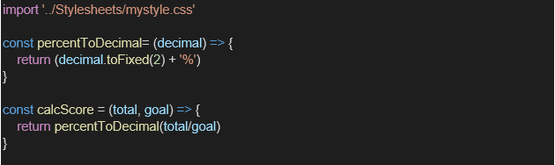
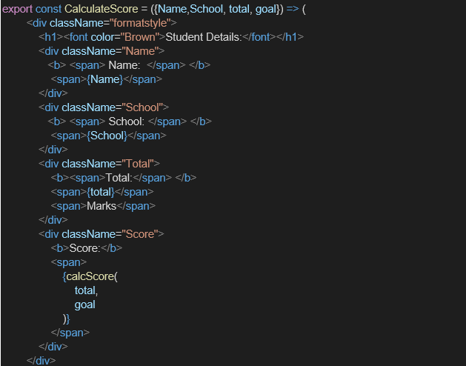

- Create a Folder named Stylesheets and add a file named “mystyle.css” in order to add some styles to the components:

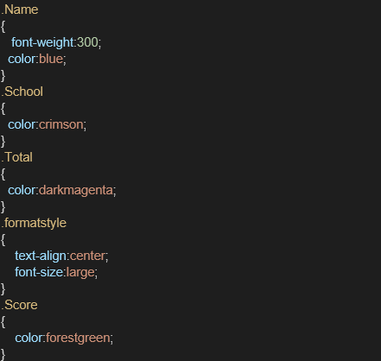

- Edit the App.js to invoke the CalculateScore functional component as follows:

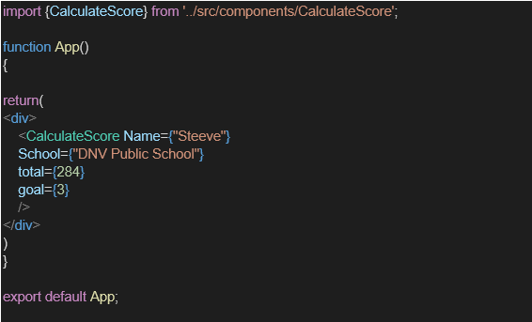

- In command Prompt, navigate into scorecalculatorapp and execute the code by typing the following command:

- Open browser and type “localhost:3000” in the address bar:

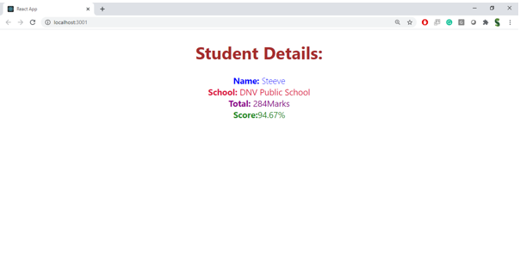
Output:
